Date | Time | Activity | Location
SEPTEMBER 2018
Wednesday 26th | 7pm | New Members Welcome Party | Brock YFC Hall
OCTOBER 2018
Wednesday 3rd | TBC | Adam’s Environmental Tour (Part 1) | The Royal Oak, Fritham
Saturday 6th | 9:30am | Ploughing Match | Bransgore  BH23 8JZ
Monday 8th | TBC | County Junior Night | Sparsholt College
Wednesday 10th | TBC | Adam’s Environmental Tour (Part 2) | TBC
Wednesday 24th | 6:30pm | Pumpkin Carving | Brock YFC Hall
NOVEMBER 2018
Wednesday 7th | 6:30pm | Boogie Bounce (£6.00 Charge) | Brock YFC Hall
Wednesday 21st | TBC | Ski Bobbing (Extra charge will apply) | Matchams Lane, BH23 6AW
DECEMBER 2018
Wednesday 5th | 6:30pm | Coffee Morning Planning Meeting | Brock YFC Hall
Friday 14th | TBC | Mince Pie Making | TBC
Saturday 15th | TBC | Mince Pie, Coffee & Carol Singing Morning | Brock YFC Hall
Wednesday 19th | TBC | Nativity followed by Christmas Party | The Fortune Centre, BH23 8EE
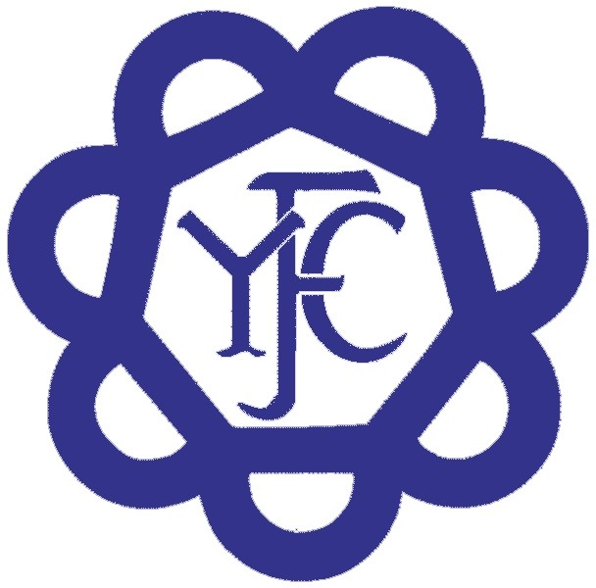
The address for the Brockenhurst Young Farmers Hall is Wotton Road, Tiptoe, SO41 6FT

Please note, this programme is subject to change and final details will be sent over prior to the meeting. All information will be confirmed via Facebook, Instagram and emails.
Facebook: Brockenhurst Young Farmers
Instagram: @Brockenhurstyoungfarmers
Email: brock.hantsyfc@gmail.com

